**THE CLOTHES SONG**

Let’s take some socks and a shirt

and hang them out on a washing line

they won’t take very long to dry

cos today the weather’s fine

Deary Deary me! It’s such a windy day!

the socks and shirt have blown away

Let’s take some shorts and a skirt

and hang them out on a washing line

they won’t take very long to dry

cos today the weather’s fine

Deary Deary me! It’s such a windy day!

The shorts and skirt have blown away

Let’s take a t-shirt and some jeans

and hang them out on a washing line

they won’t take very long to dry

cos today the weather’s fine

Deary Deary me! It’s such a windy day!

The t-shirt and jeans have blown away

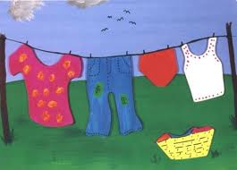Let’s take a dress that’s purple and green

and hang it out on a washing line

it won’t take very long to dry

cos today the weather’s fine

Deary Deary me! It’s such a windy day!

now the dress has blown away

Where are the sock? And the shirt?

Where are the shorts? And the skirt?

Where is the t-shirt? And the jeans?

Where is the dress that’s purple and green?

Deary Deary me! They’re stuck up in the tree!

Can you tell me all the clothes you see?

There are the socks and the shirt

There are the shorts and the skirt

There is the t-shirt and the jeans

There is the dress that’s purple and green.